EAGLES NEST AT WOLF LAUREL OWNERS ASSOCIATION, INC.
ANNUAL GENERAL MEMBERSHIP MEETING
August 9, 2025
Meeting Minutes

A quorum was declared by Elizabeth (Liza) Campa-Flanagan, Secretary, as there were members from 20 units in attendance in addition to two by proxy (total 22).

Nancy Ionoff, President called the meeting to order at 9:05 AM.

Invocation and Pledge of Allegiance was led by John Ionoff.

The agenda for the Annual General Membership Meeting, August 9, 2025 was adopted as presented as there were no additions or suggested changes to the agenda.

Minutes of the previous Annual General Member Meeting held August 12, 2024 was read to the attendees. The meeting minutes were accepted as there were no changes or additions suggested.

Election Results Reviewed by the Secretary:

The total number of ballots received either by mail or brought to the meeting was 26. All nominees received sufficient votes to carry. Additionally, there were no nominees from the floor. The Directors will serve a one year term on the Eagles Nest Board. The following nominees were elected and introduced to the attendees. Nancy Ionoff, President; Elizabeth (Liza) Campa-Flanagan, Secretary; Ken Solomon, Member at Large; Roy Miller, Treasurer; and Bob Smith, Member at Large (new member).

Nancy welcomed attendees and thanked Edmee Reyes, Vice President and Julio Romeo for their hard work and dedication to the community. Additionally, Nancy expressed her appreciation for all of Eagles Nest owner’s commitment to help their neighbors.

Nancy Ionoff introduced the current board: Nancy Ionoff, President; Edmee Reyes, Vice President; Elizabeth (Liza) Campa-Flanagan, Secretary; Ken Solomon, Member at Large; Roy Miller, Treasurer. Eagles Nest’s Financial Manager, Teresa Wilcox of Mountain Laurel Accounting was also introduced.

Officer Reports:

Prior to the official start of the Officer Reports, Marnie Sullivan asked about the lights on the upper level. Nancy Ionoff confirmed that they have been disconnected, however the wiring remains. Dan Hartley commented that the lights serve no purpose. The Board’s goal when disconnecting the lights was to eliminate the electric bill.

Motion: Marnie made a motion to remove them altogether (with the exception of the fixture near unit #704) because the fixtures accumulate bird droppings, which is unsightly. A discussion followed because Donna Mann said the fixtures are probably in concrete. Phil Gaylor asked if there is any code that requires the Board to remove the fixtures and the wiring.

Amended Motion: Ron Metcalf motioned to amend Marnie’s motion. The amended motion states that the Board will research the cost of removing the light posts.

Final Revised Motion: Dan Hartley further amended the motion as follows: “Once research regarding costs and codes has been completed and evaluated the Board shall determine whether or not to remove the light posts and/or the wiring. This was seconded by Bob Smith. The motion passed.

Al Jones asked where the meter that checks the lights is located. No one seemed to know. Nancy Ionoff said it was $20 to disconnect the lights. Al said there is probably wiring somewhere. Sue Miller said there are uncovered wires near her unit (they are not Zito). There’s a cone near the wires. Nancy Ionoff said she can have the electric company take a look. Jim Taylor said it is not electrical. Sue Miller said she can fill it in, but does she dare? Mac McLeod said the wiring could be under the pavement. Sue asked when the wires became exposed. Edmee Reyes said last year. It could be French Broad or Frontier. Edmee uses Frontier. Edmee will reach out to French Broad and Frontier. Sue Miller said that Zito said it looks like phone lines. Ron Metcalf said there’s old unused/exposed phone lines from past systems everywhere. Everyone agrees that perhaps Sue Miller should cover the hole.

Nancy Ionoff, President

- Electric Lights (mentioned above): The savings is $700 per year since the lights have been disconnected.

- Electronic Distribution of Official Business: Nancy asked if everyone is receiving electronic communication. Bob Smith and Robin Hall asked who is NOT receiving it. Everyone in attendance is receiving communications.

- Financial Manager cost increase: The fees for Mountain Laurel Accounting are increasing from $50 per hour to $65 per hour. Ken Solomon said to budget it for January and July.

- Flower Beds: Nancy mentioned that they aren’t looking too good. She has talked to Blue Mountain Owners Association (BMOA) about it. The flower beds are at the mail boxes and the Eagles Nest sign. Both are cared for by Janet Jenkins. BMOA is working on it. BMOA has a budget of $20,000 for all the flower beds.

- Rules and Regulations: The updated Rules and Regulations will be discussed later in the agenda. However, Nancy pointed out that dogs must be on a leash and dog waste must be removed by the pet owner. Be mindful that barking dogs can also be a nuisance if allowed to persist.

- BMOA update: Our fees to BMOA will have to go up. Eagles Nest Covenants, minutes, and other documents are located at bluemountainpoa.com. Teresa Wilcox created this site and it has worked well.

- Proof of Insurance: Each Eagles Nest Owner should have sent the Declarations Page to Teresa Wilcox. 16-17 Units have done so. If you have not sent the Dec Page, please send it to Mountainlaurelsolutions@outlook.com. Robin Hall suggested that Teresa send an email reminder each January 31st. A unit owner said he has not received the request. The unit owner asked Teresa for her business card. Ron Metcalf suggested that invoices from Teresa contain a request for the proof of insurance. Nancy confirmed that January of each year is a reasonable reminder time frame. Tasha Solomon and Robin Hall both agree.

Edmee Reyes, Vice President

- Painting Update: The Board finally found a painter. He had painted Edmee’s house 22 years ago. He also painted her unit 6 years ago. He was recommended by Jared Wallin. The painter has measured the units and will provide a quote on Monday or Tuesday. He’s not the least expensive, but he has a crew of 30 people. He estimates 3 months to scrape, clean, prime, and paint. Edmee will work with the Board to make sure someone is working with the painter when/if he starts the project. Ken Solomon reminded the attendees that historically the units have been painted by painters with small staffs, which caused the project to take years. Nancy Ionoff said it took a total of 3 years. Tasha Solomon asked if front porches are included. Edmee said that only back porches. Sue Miller’s was painted 6-7 years ago, but Edmee said the floor won’t be painted by the painter. Dan Hartley asked if there is a discount for those that have upgraded their decks to “never paint”. The answer is no. Dan said he plans to upgrade his deck and asked if his deck can be skipped when the painting is done in 2027. The answer is yes. Marnie Sullivan and Mac McLeod’s decks will also be skipped because they are “never paint” decks. Anyone that would prefer not to paint their deck can request it if the appearance of the deck is up to Eagles Nest standards. Nancy Ionoff reminded everyone that 2028 was the painting target, however the units will likely be painted in 2027. Phil Gaylor asked who is responsible for rotten wood. The answer is the unit owner. The last time the painters replaced wood for unit owners it was too expensive. Edmee asked the painters to notify unit owners of rotten wood. Phil Gaylor suggested that the Board ask EJ to evaluate the units and provide estimates for owners with rotten wood. This gives unit owners an option to prep prior to painting as well as provides the owners with an opportunity for price comparisons. Additionally, the Board can provide direction. Mac McLeod said he had 2 areas with rotten wood that was replaced by EJ. Mac suggested hardy board as a better alternative to wood, especially under the units. Edmee said this would need to be approved by ARB. John Hebert also commented on “hardy board”. He said it’s less expensive than wood. A unit owner said that mulch against wood can cause issues. Edmee said you can cut the wood under the units, but Dan Hartley said to proceed cautiously. The main issue is soil touching the wood. Building 400 has lots of rotten wood. Dan Hartley reminded everyone that wood has to cure, therefore Edmee will provide a one year notice for repairs prior to painting. Edmee told Mac McLeod to request that the ARB board review the hardy board. Mac said the hardy board can be painted. The ARB guidelines are under the bluemountainpoa.com website. Print and complete the form. Bob Smith asked about changing the accent color to a universal color. Edmee said that we’ve had that conversation and suggested he lead the ongoing discussion, keeping in mind that the color must blend with the storm doors and windows (hunter green and burgundy). The storm door colors can’t be changed.

Motion: A motion was made by Phil Gaylor to provide an estimate of the cost of the replacement board(s) as well as guidelines (for example: wall cost, railing cost [per foot], decking cost [per board foot]). To help unit owners planning to replace rotten wood. This was seconded by Bob Smith. Ken Solomon added that the Board should specify a contractor or provide guidance on a company that can do the job. Motion carried.

- ARB Guidelines: The goal is that gardens look neat and weed free and that dead trees are cut down. Porches should also be kept neat and clean. New A/Cs should be painted the same color as the building. A/C’s can also be covered with bushes.

Roy Miller, Treasurer; Teresa Wilcox, Financial Manager

- Revenue: Net Revenue $46,000. Owe $43,000. We are expected to be on budget. Eagles Nest owes BMOA and owes for yard maintenance. The painting reserve is in good shape. We shouldn’t need an assessment. We will have more details after we receive the painting estimate.

- BMOA: For 2026 we can’t predict what Blue Mountain Owners Association (BMOA) will do. We expect an increase of $10 per month per unit. Blue Mountain is considering taking over most of Eagles Nest’s expenses. Dan Hartley said he heard this from Jack Gilbert. Roy said we don’t know this yet. Roy Miller thinks that BMOA will have to raise dues for all districts. Roy and others believe that Eagles Nest is subsidizing Overlook. BMOA agrees, however we will have to pay BMOA more. The BMOA meeting is on September 13, 2025 where this issue will be presented. Eagles Nest (EN) may also receive an assessment from BMOA of approximately $500 - $750 per unit for 2 years to repair Ridgeway’s damage from Helene. As a reminder, we are a district of BMOA. Eagles Nest has an Association as does the Lodges. BMOA is responsible for EN snow removal, however we are subsidizing the cost of snow removal for Overlook since most of our residents are not here in the winter and the cost is greater for snow removal for Overlook. Roads are the biggest expense. Some quotes are up to $300,000. Ridgeway runs to the Preserve.

- Painting Reserve: We should have close to $180,000 by 2027. Patrick Erwin asked if a special assessment is expected for painting. The answer is, probably not. We won’t know until we have estimates.

- Quick Books: We are using quick books now. This should allow for separation between the costs incurred by each district (5 Districts): Eagles Nest (EN), The Lodges, The Cottages, Chestnut, & Overlook. The goal is to begin to maintain greater detail beginning January 1st. Note that in 2025 BMOA already paid RMS (Roads, Maintenance, & Security) about $18,000 we believe. BMOA also paid $12,500 for accounting and snow removal on behalf of EN.

- Eagles Nest Financials: Next year Eagles Nest (EN) will have to receive permission from Blue Mountain to hand out financials, since Blue Mountain has agreed to pay about $25,000 in Eagles Nest expenses. This is because we’ve determined that Eagles Nest subsidizes Chestnut and Overlook. Donna Mann asked if Overlook Village has a POA. The answer is NO. Only the Lodges and EN have their own POA. Donna Mann asked if a representative from BMOA comes to our meeting. The President, Dudley Blair usually does. He couldn’t come this time. Nancy Ionoff is on the BMOA board as well. We were planning on holding our annual meeting after Blue Mountain, however they changed their date so we don’t yet have all the answers to our questions.

- Parking Lot: Part of the expected assessment will include doing our parking lots. BMOA asked for bids to fix our parking lot. Nancy Ionoff stated that they plan to fill cracks, then chip and seal.

Unfinished Business

- Roofs: Nancy Ionoff asked Bob Smith to talk about the roofs. He said he hasn’t found much. A week ago he was referred to Jay’s roofing (referred by Jared Wallin). However, Jay’s Roofing is not doing a lot of work here now. He asked for an appraisal, but they haven’t circled back. If Bob doesn’t hear from them he will find another roofer as we need another assessment and appraisal. Edmee Reyes reminded attendees that a report was sent to unit owners: There are two roof lines on each unit, thus 2 neighbors have to work together to replace a roof. A few units had issues. It’s important to replace screws and grommets every 5 years. Note that the Lodges and the country club are about to replace roofs. This is helpful because EN can consider the same requirements. We need to ensure consistency of colors and materials. Edmee will resend the report that was sent last year. David Brown, President of the Lodges expects to replace the roofs in 2026 or 2027. We plan to piggy back for bids from the same companies. Nancy Ionoff will find out what companies to pursue. Ken Solomon mentioned that his friend who is a metallurgist explained that metal roofs should last forever if maintained. Bob Smith said that insurance companies have a different opinion. If the roofs are too old it might be difficult to obtain insurance. Roy Miller mentioned that this is already occurring here because replacement coverage is not covered if you just purchased the insurance. Many unit owners are grandfathered in. Those that aren’t may not be covered by 100% replacement cost due to the age of the roof. Sue Miller asked if we should individually replace our screws. Nancy Ionoff said yes. One of the unit owners said he trusts EJ and Chuck to do the job. Steve Ouzts said he considered an engineer to provide an unbiased roof assessment, however the cost is $9,000, which is too much. The flashing can be replaced inexpensively. Edmee Reyes said there are still 2 units with an unaddressed issue. Jim Bessel repaired a large hole where the roof had peeled back for $5,000. They didn’t have flashing or new screws.

- Insurance: Nancy thanked the insurance committee for their hard work (Jim Taylor, Phil Gaylor, & Donna Mann). The Association had no General Liability Insurance. We now have 2m with Auto Owners at a cost of about $300. Directors and Officers now have $50,000 in Crime coverage with Cincinnati Insurance at a cost of $1,205. Teresa Wilcox (Mountain Laurel Accounting) gave us a copy of her Errors & Omissions. Teresa also agreed to purchase a Surety Bond and add the Association as an additional insured. The bond will be for the amount of funds Teresa handles for the Association. We had no proof of insurance for Jamie McCurry (landscape maintenance) or other contractors. We now see that Jamie has 1m in liability, however he does not carry Workers Compensation coverage (per a unit owner). Teresa will ask Jamie. Per Jim Taylor he could get in trouble with the State if he doesn’t carry Workers Comp. Phil Gaylor said that General Liability works if we are negligent, but if they use a weed eater and it hits someone then Workers Comp would come into play. When Blue Mountain begins paying Eagles Nest’s invoices it will be an issue for Blue Mountain. Mac McLeod asked what creates liability for Eagles Nest (EN) if EN doesn’t own property. He said if EN is included in a suit then the policy covers defense costs. Mac said that in Florida if you sue an Association and the Association owns nothing then the person bringing suit has to pay all the court costs. If a lawyer brings a suit against an entity with no property then they incur all costs. Ken Solomon asked what would happen if Jamie’s employees’ equipment accidently shoot a rock at someone? Are we liable? Mac McLeod said no because the Association did not instruct/direct them. Therefore, Mac thinks the Association is probably OK.

Liability by individual owners: Each owner should have standard coverage. It used to be $300,000, however today 1m is recommended. Cindy Ouzts asked why if we are already requiring everyone to have homeowners insurance, are we requiring liability insurance. Mac McLeod said because your policy requires it. Cindy thinks it should be each owner’s problem (why do we care if we get sued for personal injury or property damage)? Phil Gaylor believes that it is irresponsible not to suggest that owners carry liability insurance. Donna Mann said that we can require 1m. If a unit owner has candles that cause 4 units to burn, the unit owner is responsible.

Motion: A motion was made by Donna Mann that the minimum requirement for Personal Liability should be 1 Million per Unit. This was seconded by Ken Solomon. This was opposed by Cindy Ouzts, however the motion carried (all in favor and 1 opposed).

- Regulations Update: Cindy Ouzts reviewed the revised Rules and Regulations, which were amended August 9, 2025. A provision was added: It is number 6 and it is regarding Energy Conservation. The provision states that “Solar Energy and other energy conservation devices are permitted with Eagles Nest ARB approval”. However, please note that ARB approval is required. It is not likely to be approved because they can’t be in the yard or on the roof. This led to a discussion of the need for Provision #6. Edmee Reyes said we don’t have much sun. Bob Smith believes the Provision would need to be more specific. He thinks the Association added this provision because BMOA allows it. Dan Hartley said State Law precludes the Association from restricting owners from having solar panel. Bob Smith asked if this applies if you are a member of an Association. He thinks Association rules might take precedent over Federal law in this case. Mac McLeod said that Federal Law applies to detached structures, therefore you can prohibit solar planes at Eagles Nest because none of the units are detached. Donna Mann suggested that we remove Provision #6. Everyone agreed that since we aren’t detached that Provision #6 should state that solar panels are not permitted on roofs or yards. Provision #11 was updated to state that “Pet owners shall be responsible for the prompt removal of pet waste. Provisions #25 now needs to be revised to include the motion that passed: “The unit owner shall provide evidence of Unit homeowners insurance annually to the Financial Manager. Each unit’s policy must include 1 million personal liability insurance (CSL – combined single limit). Provision #28 was updated to state that “gas grills and gas fire pits may be used on unit porches provided an adult (18 or older) is always on the premises while the grill is in use.

Motion: A motion was made by Phil Gaylor to accept the new regulations. This was seconded by Bob Smith. All approved and the motion carried.

- By-Laws Update: Cindy Ouzts reviewed the updates to the bylaws. PRINCIPAL OFFICES—The principal office address of the Association is Mountain Laurel Accounting Solutions, 20 Wolf Laurel Road, Suite 3, Mars Hill, NC 28754. This is the office of Teresa Wilcox; the Association’s Financial Manager. ELECTION OF OFFICERS AND DIRECTORS—Officers will be selected by the elected directors immediately after the annual meeting or as soon as possible thereafter. INSURANCE—It shall be the responsibility of the Board of Directors to purchase on behalf of the Association: (1) An insurance general liability policy protecting the Association and providing a defense of any claim against the Association in the amount of $1M per occurrence. (2) A Directors and Officers insurance policy protecting and defending the individual officers and directors from any claims made related to their actions involving the Association in the amount of $1M per occurrence. The Board will require that the Financial Manager/Property Manager obtain and maintain a Professional Liability policy with the Association as an Additional Insured and a Surety Bond at their own expense with the Association as the Obligee in the amount of no less than $150K and provide written evidence annually. The board will require that all companies or individuals who do business (such as landscape maintenance” with the Association on a regular basis provide the Financial Manager with evidence of a general liability policy in the amount of $1M or more showing the Association as an Additional Insured and a Workers Compensation policy. CHANGES TO BYLAWS—A member of the Association may request a change in the By-Laws by giving written notice to the Board of Directors’ Secretary at least 15 days prior to the annual meeting. (Note that this used to be 60 days). ASSOCIATION RECORDS—Minutes of the Association Annual Meeting shall be distributed to all Association members. The Association’s current financial statements presented at the meeting shall be included in the distributed information. Electronic communications are acceptable.

Motion: A motion was made by Mac McLeod to accept the updated bylaws. This was seconded by Dan Hartley. All were in favor. The motion passed.

New Business

None

Questions and Answers

Ken Solomon asked if we have an option with regard to the increasing fees from Blue Mountain. Nancy Ionoff said that the fees can go up to $15 per month per year per unit. Ken asked if the Board can increase the fees without a vote. Nancy said that we vote as a courtesy.

Adjournment

A motion was made by Jim Taylor that we adjourn. Bob Smith seconded the motion. The meeting was adjourned at 11:30 AM.

Respectfully submitted,

Liza Campa-Flanagan, Secretary Eagles Nest at Wolf Laurel HOA

ATTACHMENTS (MOST WERE HANDOUTS)

Rules and Regulations Handout:

RULES AND REGULATIONS FOR EAGLES NEST OWNERS
AS APPROVED AUGUST 6, 2005 (AMENDED AUGUST 2, 2014)
(AMENDED JUNE 10, 2017, AMENDED AUGUST 9, 2025)

THE FOLLOWING IS A SUMMARY OF THE RULES AND REGULATIONS OF THE
EAGLES NEST OWNERS’ ASSOCIATION MEMBERSHIP:

ITEMS ONE (1) THROUGH FOURTEEN (14) ARE SUMMARY EXCERPTS FROM THE DECLARATION OF COVENANTS. (ARTICLE VI), TITLED “USE RESTRICTIONS”:

In order to provide for congenial occupancy of the Property and for the protection of the value of the Dwelling Units, the use of the property shall be in accordance with the following provisions:

1. Residential Uses. Dwelling Units shall be used as residential living units and for no other purpose.

2. Antennae. No aerial antennae, satellite receptor dish or similar device shall be placed or erected upon or affixed in any manner to the exterior of any Dwelling Unit except with prior approval of the Board of Directors of the Association and the Architectural Review Board (ARB).

3. Clothes Drying Area. No part of any unit shall be used as a drying or hanging area for laundry.

4. Nuisances. Nothing shall be done or kept in any Dwelling Unit which may be or become an annoyance or nuisance to the other property owners.

5. Signs. No signs may be placed at any Dwelling Unit without the Prior approval of the Board of Directors of the Association and the ARB.

6. Energy Conservation. Solar Energy and other energy conservation devices are permitted with Eagles Nest ARB approval. Solar panels are not permitted on the roofs or grounds of Eagles Nest.

7. Window Coverings. No reflective window coverings or treatments shall be allowed.

8. Insurance. Nothing shall be done or kept at any Dwelling Unit or on the common property, which will increase the rate of insurance covering the Property. No owner shall allow anything to be done or kept in his/her Dwelling Unit which shall result in the cancellation of insurance on the Property, or which would be in violation of any law.

9. Off Street Motor Vehicles, Boats, RV’s, Motorcycles, Trailers and/or other oversized vehicles: No motorized vehicles including, without limitation, two and three wheel all terrain vehicles or “dirt bikes” may be operated off of the common roads, paved roadways and drives. Boats, RV’s Motorcycles, Trailers and/or other oversized vehicles are not permitted in the common parking areas, except for a singles night until a parking location can be found.

10. Noise. Established Quiet Hours are from 11:00 p.m. until 7:30 a.m. and there should be no excess noise so as not to constitute a nuisance or unreasonable annoyance to neighbors.

11. Pets. No more than two (2) common domestic household pets. No pets shall be allowed to make an unreasonable amount of noise or to become a nuisance; and no pets will be allowed on the property other than on the lot or in the Unit of the owner of such pets, unless confined to a leash. No pet shall be allowed to run at large. Pet owners shall be responsible for the prompt removal and disposal of pet waste.

12. Lawful Use. No immoral, improper, offensive or unlawful use shall be made of the property or any part thereof and all valid laws, zoning ordinances, and regulations of all governmental bodies having jurisdiction thereof shall be observed.

13. Hazardous Materials. No hazardous or toxic materials or pollutants shall be discharged, maintained, stored, released or disposed of on the property except in strict compliance with applicable rules and regulations.

14. Additional Use Restrictions. The Board of Directors of the Association may adopt such additional use restrictions, rules or regulations; and may waive or modify application of the foregoing use restrictions with respect to any Unit(s) as the Board, in its sole discretion, deems appropriate. IN KEEPING WITH THIS COVENANT, THE BOARD HAS ADDED THE FOLLOWING RULES NUMBERED FIFTEEN (15) THROUGH THIRTY-FIVE (35):

RESPONSIBILITIES OF THE BOARD OF DIRECTORS

15. The Board of Directors of the Association may adopt such added use restrictions, rules or regulations
as the Board in its sole discretion considers appropriate.

16. The Board of Directors of the Association is responsible for enforcing the Rules and Regulations of the Association.

17. The Board of Directors of the Association is empowered to institute legal action, as necessary, to assure compliance with the Rules and Regulations of the Association and shall be held harmless for actions taken in the interest of all Unit owners.

18. The Board of Directors of the Association sets all Assessments and Special Assessments. Assessments are delinquent on the tenth (10th) day after the due date. Delinquent accounts are required to pay a $15.00 late fee. Account delinquencies will be charged an additional 1.5 percent per month until the account is made current. Delinquencies after sixty (60) days will be subject to a property lien and will be required to pay all costs, including legal and administrative fees to place and subsequently remove the lien.

19. The Board of Directors of the Association and the ARB are responsible for the prior approval of all physical changes to Unit exteriors or common areas. Further they are also responsible for the prior approval of all tree or shrub cutting and/or removal.

20. The Board of Directors of the Association is responsible for providing the most current Rules and Regulations of the Association to each Unit owner in a timely manner.

21. The Executive Committee of the Board of Directors shall cause regular inspections to be made of the exterior of the Unit Complex during the months October through May.

RESPONSIBILITIES OF UNIT OWNERS

22. All Unit owners are required to pay Assessments and Special Assessments as set by the Board of Directors of the Association. (See Rule 18)

23. Unit owners shall not make any physical changes to the exterior of their Unit or the common areas without Prior approval of the Board of Directors. (See Rule.19)

24. In the event an owner sells or otherwise transfers Unit ownership, he/she shall notify the Financial Manager/Property Manager of such transfer within 30 days.

25. The Unit owner shall provide evidence of Unit homeowners insurance annually to the Financial Manager/Property Manager.

26. All Unit owners are responsible for watering their landscape in the summer months. If plants, shrubs or trees die and are not replaced with a reasonable time frame, the Association will replace them and bill the Unit owner.

27. All Unit owners are individually responsible for “winterizing” and “pest control” of their property to avoid damaging other Units and the common property.

28. No Charcoal grills or smokers are permitted to be used on Unit porches. Any such food preparation must be done in the open yards of the Units so as not to be a fire hazard to the Unit or the Complex. Gas grills and gas firepits may be used on Unit porches provided an adult (eighteen (18) years or older) is always on the premises while the grill is in use.

29. All tree or shrub cutting and/or removal is subject to the rules established by the Blue Mountain ARB and are subject to prior approval of the Board of Directors of the Association and the ARB. Requests should be made in writing and submitted to the Board for approval. (See Rule 19.)

30. Unit owners are not permitted to accumulate trash or other items that would be visible to the common areas.

31. Unit owners with pets (and visitors, in their rental units and/or in their residences) who are found to be non-compliant with Item 11, and/or, have unusually noisy pets to the extent that there are existing complaints submitted to the Board, will be notified and given thirty (30) days to correct the problem. If not corrected within that period, the Unit owner may be subject to a fine of not less than ($50) dollars per day.

RESPONSIBILITIES OF UNIT OWNERS WHO RENT THEIR UNITS

32. Unit owners are expected to notify the Board of Directors of the Association in January of each year if their Unit is in the Rental Pool.

33. Owners who rent are responsible for the conduct of the renter and their guests and any damages to common property.

34. Renters are not allowed to accumulate trash or items that would be visible to the common property.

35. Unit owners are responsible for providing written notification to rental agents, renters and their guests of the most recent Rules and Regulations of the Association.
--------------------------------------------------------------------------------------------------------------
By-Laws Handout

OF

EAGLES NEST AT WOLF LAUREL OWNERS ASSOCIATION, INC

The following By-Laws of the Eagles Nest Owners Association were adopted this 7th day of August in the year 1993 (As amended, August 6, 2005, and August 2, 2014, August 9, 2025).

IDENTITY

The name of the Association shall be , “Eagles Nest at Wolf Laurel Owners Association” (The Association), a not-for-profit association operating under the laws of the State of North Carolina, organized for the purpose of administering the affairs of The Association, involving 36 town home villas located at Blue Mountain Resort in Madison and Yancey counties of North Carolina.

PRINCIPAL OFFICES

The Board of Directors shall designate the principal office of The Association.

The principal office address as of this date is:

Mountain Laurel Accounting Solutions
20 Wolf Laurel Road, Suite 3
Mars Hill, NC 28754
828-450-9780

The mailing address is:

P0 Box 1150
Mars Hill, NC 28754

All books and records of The Association shall be maintained at the principal office.

MEMBERSHIP

The membership shall consist of the owners of Eagles Nest Villas.

It shall be the responsibility of each villa owner to keep the Financial Manager/Property Manager informed of their current address, phone number and email and/or the sale or transfer of their villa to a new owner.

NOTICES

The annual meeting shall be held at a time determined by the Board and written notice of the Annual Meeting shall be given not more than forty-five (45) days and not less than thirty (30) days prior to the meeting. Special meetings may be called, provided proper notice is given, by any five (5) Association members.

ELECTION OF OFFICERS AND DIRECTORS

Directors shall be nominated and voted on at the Annual Meeting of The Association.

Balloting may be conducted by ballot, or by show of hand; and a simple majority of those present in person (or by proxy) shall be sufficient to elect a director.

Any three members present may request a secret ballot; and a secret ballot must be held.

Each villa is entitled to one vote.

Officers will be selected by the elected directors immediately after the annual meeting or as soon as possible thereafter.

EXPENSES OF OFFICERS AND DIRECTORS

It is understood and agreed that expenses incurred by officers and directors on Association business such as travel to and from meetings, meals, etc., shall be the responsibility of the individual director; and will not be reimbursed by The Association.

OFFICERS AND DIRECTORS

All officers and directors must be a member of the Association. The officers shall consist of the following:

President
Vice President
Secretary
Treasurer

The term for officers shall be one year. Any officer may be re-elected.

The Board of Directors shall consist of a total of five (5) directors, made up of four (4) Officers and one (1) association member elected for a one (1) year term as Directors. Directors may be re-elected.

The Executive Committee is comprised of the Officers and has authority to act on behalf of the Board, as required from time to time, between Board Meetings.

Insurance

It shall be the responsibility of the Board of Directors to purchase on behalf of the Association:
- An insurance general liability policy protecting the Association and providing a defense of any claim against the Association in the amount of $1M per occurrence.
- A Directors and Officers insurance policy protecting and defending the individual officers and directors from any claims made related to their actions involving the Association in the amount of $1M per occurrence.
The Board will require that the Financial Manager/Property Manager obtain and maintain a Professional Liability policy with the Association as an Additional Insured and a Surety Bond at their own expense with the Association as the Obligee in the amount of no less than $150K and provide written evidence annually.
The Board will require that all companies or individuals who do business (such as landscape maintenance) with the Association on a regular basis provide the Financial Manager with evidence of a general liability policy in the amount of $1M or more showing the Association as an Additional Insured and a Workers Compensation policy.

This section has been replaced by the above.

INSURANCE

It shall be the responsibility of the Board of Directors to purchase a bond in an amount not less than $50,000 for the protection of The Association on any Officer or Financial Manager/Property Manager who has the authority to disburse (or authorize disbursement of) Association funds.

It shall be the responsibility of the Board of Directors to purchase Director & Officer’s Liability Insurance in an amount not less than $1,000,000 for the benefit of anyone serving as a Director or Officer.

The cost of the above-listed insurance shall be an expense paid for with The Association funds.

BOARD OF DIRECTORS

RESPONSIBILITY

The Board of Directors shall manage the affairs of The Association. Members shall be bound by their decisions which are not specifically hereinafter excluded.

Decisions of the Board which shall not be binding upon
The villa owners without the members voting approval are.
as follows:

1) Change in the monthly maintenance fees.
2) Increase of the fees paid to the Blue Mountain Property Owners Association.
3) Any assessment more than $100 (other than for emergencies) for the purpose of maintaining the villas.
4) Rules or regulations binding upon Association membership.

QUORUM. PROXY AND VOTING

For the purpose of conducting official business by the Board of Directors, a quorum shall consist of no less than three (3) Directors.
For the purpose of conducting business at The Association Annual Meetings (or at Special Meetings), a quorum shall consist of no less than twelve (12) members present (or represented by proxy). Business conducted without a quorum shall not be binding upon The Association.

A signed, written proxy shall be recognized as a member present and the person whose name appears on the proxy shall have the right to vote the proxy for the non-present member as if he/she were present.

A simple majority vote to approve a proposed action or resolution shall prevail. Each villa is entitled to one vote.

FINANCIAL MANAGER/PROPERTY MANAGER

The Financial Manager/Property Manager shall conduct the day-to-day affairs of The Association, maintain financial books of record, collect funds, make money deposits, pay Association obligations and provide monthly financial statements to the Board of Directors.

The Financial Manager/Property Manager shall have no vote at any meeting conducted by the Association unless he or she is a villa owner entitled to such Financial Manager/Property Manager shall serve at the discretion of the Board of Directors.

CHANGES TO BY-LAWS

The Board of Directors shall present recommendations for changes (if any) to the By-Laws at The Association Annual Meeting.

A member of the Association may request a change in the By-Laws by giving written notice to the Board of Directors’ Secretary at least 15 days prior to the annual meeting.

A timely request for change(s) to the By-Laws shall be presented to the membership along with the Board’s recommendation(s) at The Association Annual Meeting. At the Board’s sole discretion, late requests for changes to the By-Laws may be presented at the meeting or deferred until the next scheduled annual meeting.

By-Laws may be changed by a majority vote of The Association members attending (or represented by proxy at) the Annual Meeting.

ASSOCIATION RECORDS

Minutes of The Association Annual Meeting shall be distributed to all Association members. The Association’s current financial statements presented at the meeting shall be included in the distributed information. Electronic communications are acceptable

The Financial Manager/Property Manager shall maintain The Association records at the offices of The Association; and make such records available for review and examination, at the offices of The Association, to any member requesting access.

EMERGENCY ACTIONS BY THE BOARD

In the event of an emergency, the Board of Directors Executive Committee (consisting of the officers) is empowered to take whatever action it deems advisable, consistent with that which a prudent person would take, to protect the Association’s assets or property and the personal property of Association members.

The Association shall be reimbursed by the Association member for the cost of any such emergency action taken on their behalf.

ADDENDUM TO THE SUPPLEMENT OF THE
BLUE MOUNTAIN PROPERTY OWNERS’ ASSOCIATION COVENANTS
ESTABLISHING THE
THE EAGLES NEST (TOWNHOME) DISTRICT.

BE IT RESOLVED BY ACCLAMATION OF THE “EAGLES NEST
PROPERTY OWNERS’ ASSOCIATION”, DURING ITS ANNUAL MEETING ON
AUGUST 7, 1993, THAT THE FOLLOWING ADDENDUM TO THE “BLUE
MOUNTAIN PROPERTY OWNERS’ ASSOCIATION, INC.” SUPPLEMENTAL
COVENANT (CREATING THE EAGLES NEST TOWNHOME DISTRICT BE
CLARIFIED AS FOLLOWS:

It is the intent of the EAGLES NEST OWNERS ASSOCIATION that the interpretation of ARTICLE 11.3 of the above referenced covenant is to be based on this clarification; wherein, “The ASSOCIATION is responsible only for painting the exterior of the Villas, and lawn maintenance as such become necessary to preserve the esthetics of the Villa complex. Each owner is individually responsible for insuring his/her townhome villa against casualty losses to both the interior and exterior of the structure. The ASSOCIATION shall not be responsible for any repairs which may from time to time be required to any of the villas exterior or interior; the Association may however cause repairs to be made to the exterior for the owners account in the event of an emergency, or if unsightly damage or needed repair is not corrected by the owner within a reasonable period of time. Each villa owner acknowledges his or her obligation outlined above; and further warrants that this obligation shall be extended to any subsequent transfer or assignment of their Eagles Nest Property.”

--------------------------------------------------------------------------------------------------------------

2024 MINUTES (READ ALOUD TO ATTENDEES) –NOT A HANDOUT

Page | 1
EAGLES NEST AT WOLF LAUREL OWNERS ASSOCIATION, INC.
ANNUAL GENERAL MEMBERSHIP MEETING
August 12, 2024
Meeting Minutes
A quorum was declared by Carolyn Traylor, Secretary, given there were members from 22 units in
attendance with 7 additional units represented by proxy.
Nancy Ionoff, President, called the meeting to order at 9:08.
Invocation and Pledge of Allegiance was led by John Ionoff.
The agenda was adopted as presented.
Minutes of the previous Annual General Membership Meeting held July 10, 2023, were approved.
Introduction of the current board was made. Nancy Ionoff, President; Edmee Reyes, Vice President; Roy
Miller, Treasurer; Carolyn Traylor, Secretary; and Cindy Ouzts, Member At Large.
Teresa Wilcox, Financial Manager, and Jered Silver, Property Manager for Blue Mountain Owners
Association, were Introduced.
Dudley Blair, President of Blue Mountain Owners Association (BMOA) was introduced. He praised the
fact that so many members of Eagles Nest were in attendance and reminded the membership that their
participation is important and that the board members are unpaid volunteers.

Officer Reports:

Nancy Ionoff, President
1. Package Delivery Update: There have been no changes since last year.
Members must belong to the Property Owners Association to receive packages from anyone other than
the USPS. One can have UPS packages left at the UPS store.
2. Parking Lot Cracks: Jered Silver indicated that there is obvious settlement in the parking lots
probably due to the organic material that is underneath the parking lot. If the material is deep a
complete replacement will be expensive. To determine the depth of the underground material bore
holes can be drilled; however, this could cost as much as $100,000. Additionally, removing the organic
material and resurface the parking lot would probably be cost prohibitive. He suggested repairing the
cracks and repaving the lots. He indicated that this should last between 5-15 years, if done well.
However, he warned that with these patches there would continue to be resettled and therefore the
need to again repair after a period of time; but that this still should be the most cost-effective way to
proceed.
Because the parking lots are owned by BMOA, Dudley Blair reported that BMOA will entertain a
recommendation from the Eagles Nest Board concerning the parking lot as it receives information
and/or bids. The Eagles Nest Board will further review the information from Max Fox and Jared Silver
Page | 2
and work with BMOA concerning the issues. Jered Silver will work to find other licensed and competent
contractors who can also assess the issue and give bids.
3. Teresa Wilcox gave information concerning the new website which can be accessed
through www.bluemountainpoa.com.

Edmee Reyes, Vice President
1. The Architectural Review Board (ARB): The ARB Document which was sent out last year will be
placed on the website. She reminded homeowners that if they are planning to do anything
concerning the outside of their units, they must apply to do so using the ARB process beginning
with completing an application.
2. Paint Colors: Paint colors will be available on the website.
3. Parking Lots Lighting: Many of the parking lot lights have not been working at all or are working
poorly. We are paying $700.00 per year to French Broad for this lighting. After discussion a
motion was made, seconded and passed that using a licensed electrician we permanently
disconnect and remove the lights.

Carolyn Traylor, Secretary
1. Election Results: The following were elected to the Eagles Nest Board for a one year term:
Nancy Ionoff
Edmee Reyes
Roy Miller
Liza Campa Flanigan
Ken Soloman

Roy Miller, Treasurer; Teresa Wilcox, Financial Manager
1. Dues: Dues for the current year will remain the same.
2. Assessments to Blue Mountain: The EN Board is reviewing the money which is given to BMOA in
order to discuss with Blue Mountain how our money is allocated. Currently $150 per month,
per unit is given to Blue Mountain.
3. Paint Reserve: Projections indicate that we are financially on track with the painting reserve
fund. Edmee Reyes is working on obtaining two current estimates for painting our buildings to
make certain that this is still funded sufficiently. It is estimated that we will begin painting in
2027.
Page | 3
4. Budget: Roy Miller indicated that our budget is in good shape, see Budget as sent to members.
Teresa Wilcox reported that a CPA firm has been hired to file our tax return.

Unfinished Business:
1. Roofs: Cindy Ouzts reviewed the status of the responsibility of our roofs. The Villas were
built between 1990-1991. Our covenants indicate that the roofs are the individual owner’s
responsibility to maintain and replace. This is problematic as our roofs are connected such
that when one person needs to replace their roof, they would need their neighbor to also
replace theirs. To change the covenant EN must go through Blue Mountain which will
require 75% of the Blue Mountain owners agreeing to this change. This will be difficult to
obtain.
Motion was made, seconded and passed that the Eagles Nest Board pay to have an
evaluation of our roofs conducted.
After obtaining information concerning the evaluation of the roofs the EN Board will send a
questionnaire to owners asking for input as to whether to pursue attempting to change the
Blue Mountain covenants such that EN could begin a reserve fund for the roofs.

New Business:
1. Update of Bylaws: The EN Board plans to update the current EN Bylaws especially
concerning where there are conflicts or need for clarification.
2. Electronic Distribution of Official Business: A motion was made, seconded and passed that
official business can be conducted through electronic distribution such as email.

Questions and Answers:
1. A motion was made, seconded and passed that the EN Board appoint a committee of 3
people to determine why Eagles Nest does not have general liability insurance and report to
the board in 60 days.
2. Nancy Ionoff appointed Donna Mann, Jim Taylor, and Phil Gaynor to the above committee.
Additionally, she tasked the above committee with determining a recommendation for
homeowners as to the amount of liability insurance that they should carry.
3. The EN board will develop a process of how to enforce the proof of insurance which is
currently a requirement per our Bylaws.
Page | 4

Adjournment:
1. The meeting was adjourned at 11:14.
Respectfully Submitted,
Carolyn Traylor
Secretary, Eagles Nest at Wolf Laurel HOA
Page | 5
--------------------------------------------------------------------------------------------------------------
FINANCIALS HANDOUTS (2):
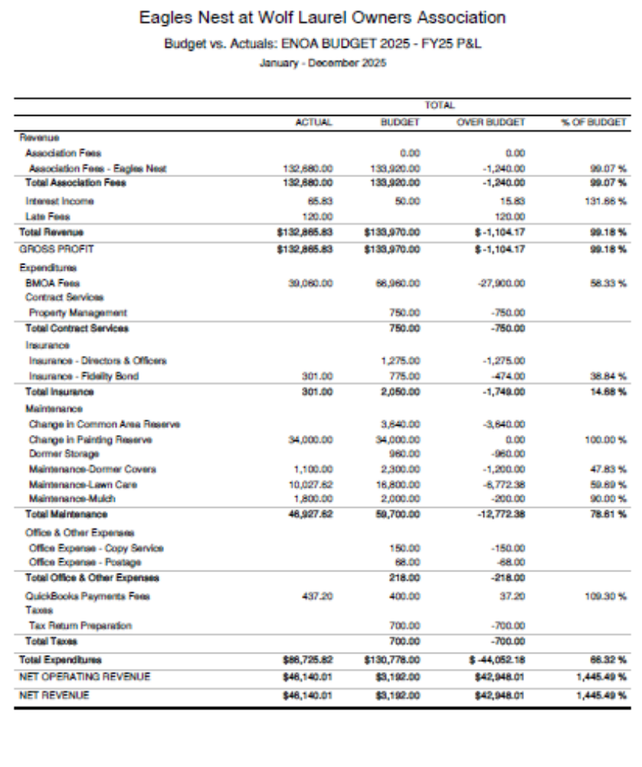
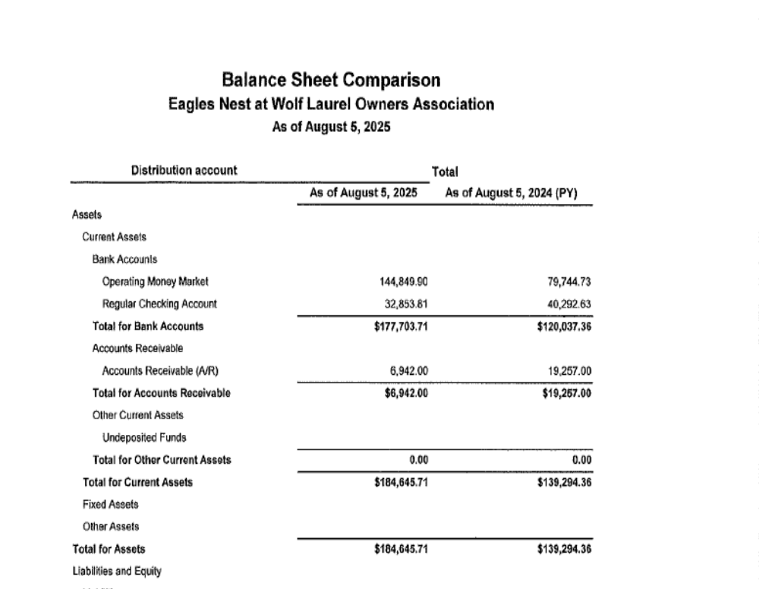

Continued Next Page:
